# Word count: 225

# What to bring to create your online sign-in account

If you have an appointment with a VA staff member to get help to create a **Login.gov** or **ID.me** account, be sure you come prepared.

## What to bring to create a Login.gov account

* A unique personal email address that only you use
* Your Social Security number
* Your U.S. phone number or mailing address
* Your current, valid state-issued driver’s license or non-driver’s license ID card
* Your personal mobile phone or other mobile device (if you have one)

## What to bring to create an ID.me account

* A unique personal email address that only you use
* Your Social Security number (if you have one)
* Your U.S. phone number or mailing address (if you have one)
* Your personal mobile phone or other mobile device (if you have one)
* A state-issued driver’s license, non-driver’s license ID card, U.S. passport, or passport card
* 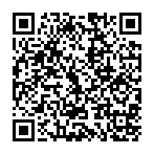More ID documents if you recently changed your legal name or address, want to verify on a video call, or live outside the U.S. To learn more about primary and secondary documents for ID.me, scan the QR code or go to <https://help.id.me/hc/en-us/articles/360017833054-Primary-and-secondary-identification-documents>.

Learn more about sign in changes coming to VA

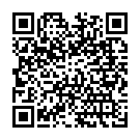And get more instructions for how to create your account and verify your identity.  Go to [www.va.gov/sign-in-changes](http://www.va.gov/sign-in-changes).  